H.T No
Regulations:
A22

Sreenidhi Institute of Science and Technology
(An Autonomous Institution)
Code No:9B512 Date:21-January-2025 (AN)

B.Tech III-Year I- Semester External Examination, January-2025 (Regular)
DESIGN OF MACHINE ELEMENTS (MECHANICAL)

Time: 3 Hours Max.Marks:60

Note: a) No additional answer sheets will be provided.
b) All sub-parts of a question must be answered at one place only, otherwise it will not be valued.
c) Missing data can be assumed suitably. Design hand book not necssary.
Bloom's Cognitive Levels of Learning (BCLL)

Remember | L1 | Apply | L3 | Evaluate | L5
Understand | L2 | Analyze | L4 | Create | L6

Part - A Max.Marks: 6x2=12

Answer all QUESTIONS, EACH QUESTION CARRIES 2 MARKS.

 |  | BCLL | CO(s) | Marks
1 | What is factor of safety? Explain Briefly. | L1 | CO1 | [2M]
2 | Define Notch Sensitivity. | L2 | CO1 | [2M]
3 | List the Classification of Couplings. | L1 | CO2 | [2M]
4 | What is the spring index? Why is it used? | L1 | CO3 | [2M]
5 | Draw a double chain riveted lap joint. | L1 | CO4 | [2M]
6 | What is Fillet Welding ? | L2 | CO4 | [2M]

Part – B Max.Marks: 6x8=48
ANSWER ALL QUESTIONS. EACH QUESTION CARRIES 8 MARKS.

 |  | BCLL | CO(s) | Marks
7. | Explain the basics of the Machine Design theories of failures. | L6 | CO1 | [8M]
 | OR
8 | A steel shaft 1.2 m long between bearings carries 2000 N pulley at its mid-point. The pulley keyed to the shaft and receives 20 KW power at 200 RPM. The diameter of pulley is 600mm. The load is applied with moderate shocks, calculate the necessary shaft diameter. Take S_{yt} =320MPa. | L5 | CO1 | [8M]
9. | What is meant by endurance strength of a material? Explain Goodman's equation. | L2 | CO1 | [8M]
 | OR
10 | A circular rod of 500 mm length is supported freely at its two ends. It is acted upon by a central concentrated cyclic load having a minimum value of 20 kN and a maximum value of 50 kN. Determine the diameter of rod by taking a factor of safety of 1.5, size effect of 0.85, surface finish factor of 0.9. The material properties of bar are given by: ultimate strength of 650 MPa, yield strength of 500 MPa and endurance strength of 350 MPa. K_{f}=1.2 Use good man equation. | L5 | CO1 | [8M]
11. | What are keys? Give their applications and the design steps with expressions of a sunk key of rectangular cross section. . | L2 | CO2 | [8M]
 | OR
12 | Design a cast iron flange coupling for a steel shaft transmitting 15 kW at 200 rpm. and having an allowable shear stress of 40 N/mm². The working stress in the bolts should not exceed 30 N/mm². Assume that the same material is used for shaft and key and that the crushing stress is twice the value of its shear stress. The shear stress for cast iron is 14 N/mm². | L6 | CO2 | [8M]
13. | A leaf spring has 12 number of leaves, two of which are full length leaves. The spring supports are 1.05 m apart and the central band is 85 mm wide. The central load is to be 5.4 kN with a permissible stress of 280 MPa. Determine the thickness and width of the steel spring leaves. The ratio of the total depth to the width of the spring is 3. Also determine the deflection of the spring. | L5 | CO3 | [8M]
 | OR
14 | Design of on helical compression spring used for operating a valve. The spring is subjected to a load of 150 N, The deflection of the spring, is 7mm.Take spring index as 6. Determine the size of the wire, size and number of coils, and pitch of the coils. permissible shear stress 480 MPa | L6 | CO3 | [8M]
15. | Two mild steel flat plates 200 mm × 10 mm are to be connected by a double riveted double cover butt joint, Design the riveted joint, if the allowable working stresses are 112 MPa in tension, 84 MPa in shear and 200 MPa in crushing. Take thickness of plates as 10 mm | L6 | CO4 | [8M]
 | OR
16 | A V threaded bolt of a 100 mm core diameter and 20 mm pitch supports a load of 18 KN. The stiffness of the bolt is double the components stiffness. Find the equivalent load and tensile stress. | L4 | CO4 | [8M]
17. | Explain how to calculate the filled weld length in symmetrical and un symmetrical double parallel fillet weld joint. | L2 | CO4 | [8M]
 | OR
18 | 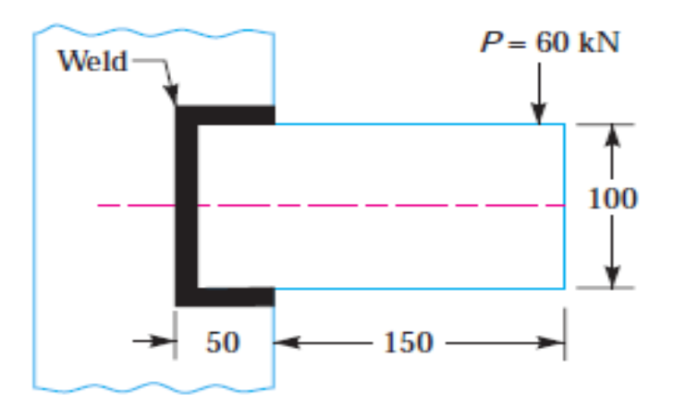  A rectangular steel plate is welded as a cantilever to a vertical column and supports a single concentrated load P, as shown in Figure. Determine the weld size if shear stress in the same is not to exceed 140 MPa. (Dimensions are in mm). | L3 | CO4 | [8M]

-- 00 -- 00 –

